DOCUMENTATION BY SANTOSH
This Documentation is all about :-
“ Deploying Java Application Using GitHub Repository in the Tomcat Server with Jenkins and Maven “.
Step 1 :- Installing Vmware Workstation.
Step 2 :- Booting “ RED HAT 9 “ ( i.e RHEL LINUX – 9 )
Installing Jenkins by using Yum :-
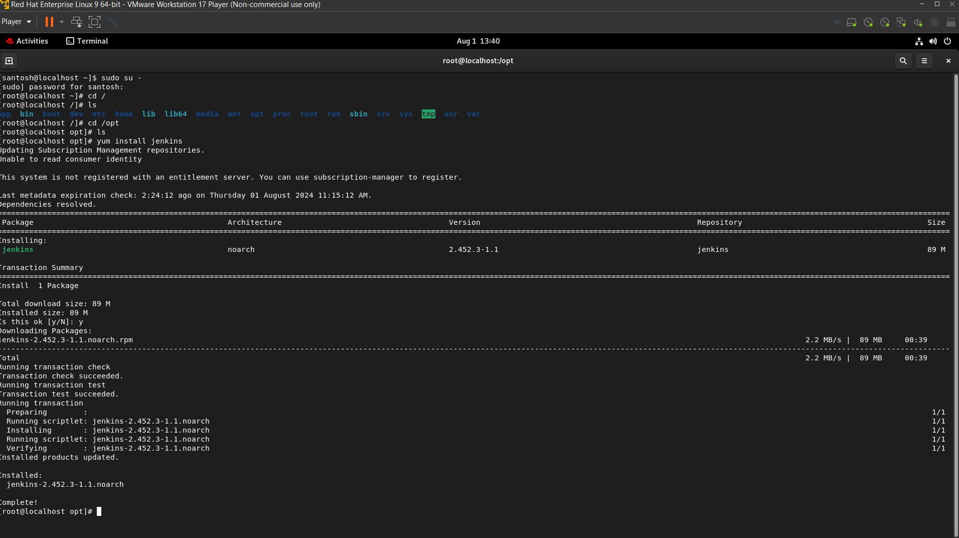
Use the following commands to enable , start and to check the status of your Jenkins.
Systemctl enable jenkins.service
Systemctl start Jenkins.service
Systemctl status Jenkins.service .
1.2 )Note :- install java11 or 17 then check java –version to confirm installation.
Default Jenkins port number : 8080
Changed Jenkins port number : 8019
To change port number for Jenkins : - Vi /usr/lib/system/system/Jenkins.service
Note : - use ” i “ once you entered into vi editor to insert
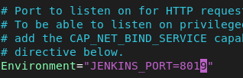
Note : - after changing port number then to save & quit vi editor
Use Esc then enter this command :wq
- Systemctl restart jenkins.service to make sure changes applied
- After restar use netstat -plntu & curl localhost:your_port_id
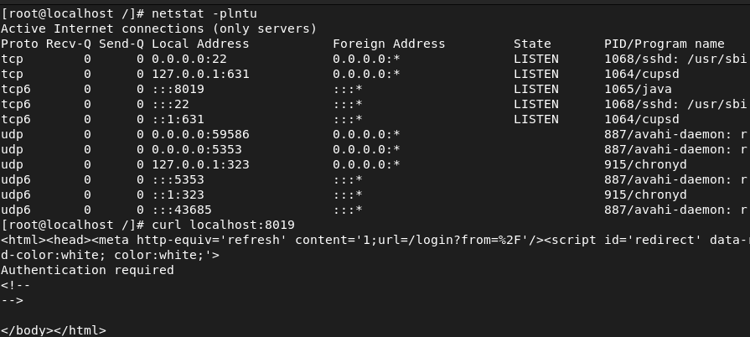
Then Login to Jenkins server by using Jenkins credentials .
- Install Git in Jenkins server : - # Become a root and use these following commands.
sudo su -
2.1 ) yum install git -y
git version ( or git --version )
- Now go root user sudo su – then go to /opt directory to install tomcat. then go to apache tomcat website to download repository.
To download tomcat 9 .
https://tomcat.apache.org/download-90.cgi
then download any .tar file to download as zip file , use the following link provided with wget command to download.
wget https://dlcdn.apache.org/tomcat/tomcat-9/v9.0.91/bin/apache-tomcat-9.0.91.tar.gz
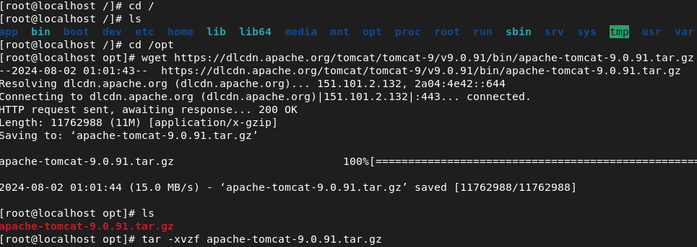
# unzip tomcat binary
tar -xvzf apache-tomcat-9.0.91
# Rename for simplicity
mv apache-tomcat-9.0.01 tomcat (rename)
# Become a root , no need to execute this cmd if your already root user.
sudo su -

2.2 ) # create a tomcat user
adduser tomcat
# create a password for tomcat user
passwd tomcat
# enter the New password then Retype new password, you should see passwd: all authentication tokens updated successfully.
- Now change the ownership of /opt/tomcat file from root to tomcat being a root user.
chown -R tomcat:tomcat /opt/tomcat
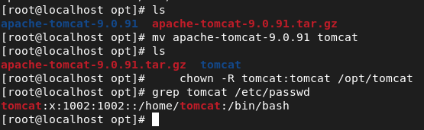
- Use the following commands as show in the image .
To start tomcat server & to check tomcat port is listening or not.

3.1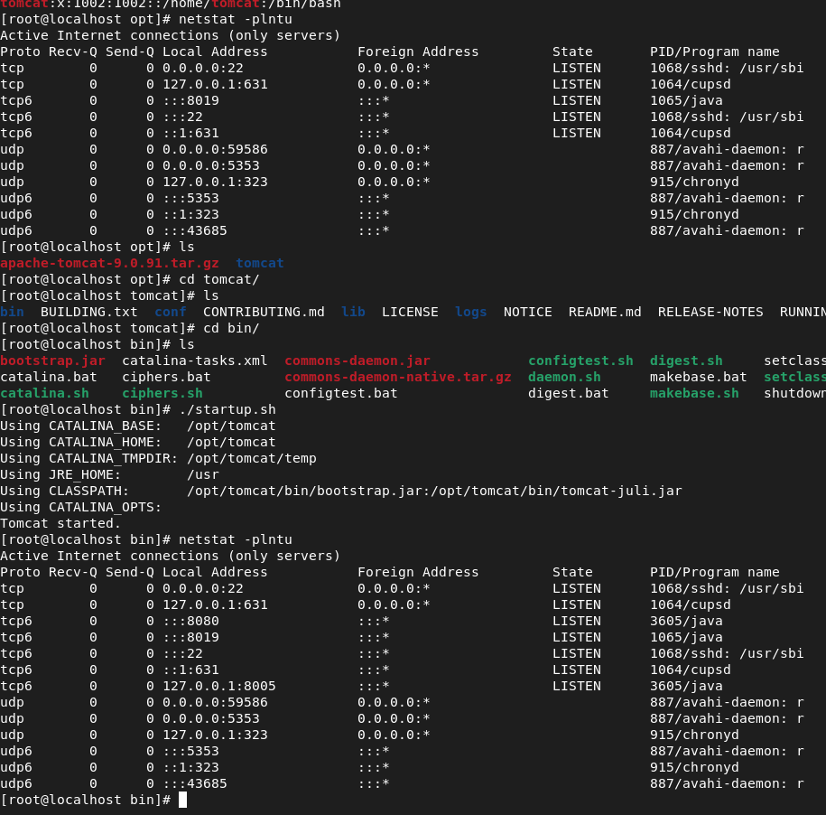
Then use localhost:8080 in your browser (or) type this command for tomcat UI “ curl localhost:8080 “.
=> Now switch to tomcat user and make following changes.
su - tomcat
cd /opt/tomcat
# Create a tomcat user and assign manager-gui, manager-script ,manager-jmx, manager-status roles.
vi conf/tomcat-users.xml
3.2 # Add the below line before tomcat-users-tag.
<user username="your_name" password="your_password" roles="manager-gui,manager-script,manager-jmx,manager-status"/>
</tomcat-users>
press Esc :wq
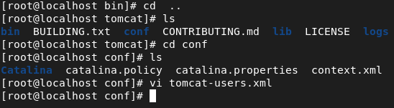
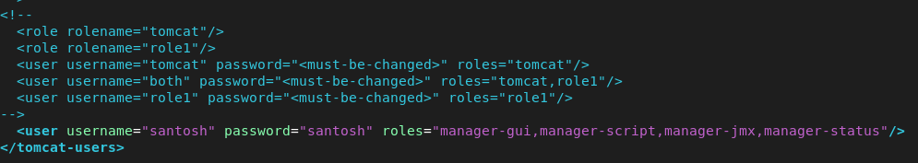
# enter the below command in tomcat directory.
find / -name context.xml
# you will see the following lines.
./conf/context.xml
./webapps/docs/META-INF/context.xml
./webapps/examples/META-INF/context.xml
./webapps/host-manager/META-INF/context.xml
./webapps/manager/META-INF/context.xml
#comment value tag sections in below all files
vi ./webapps/examples/META-INF/context.xml
vi ./webapps/host-manager/META-INF/context.xml
vi ./webapps/manager/META-INF/context.xml
4.1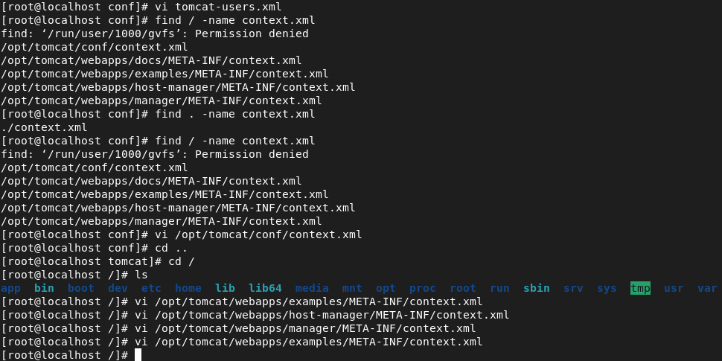
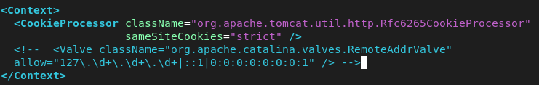
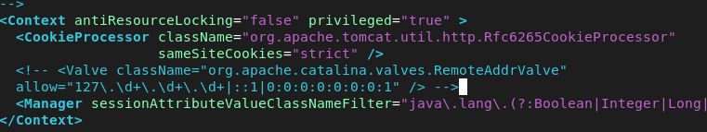
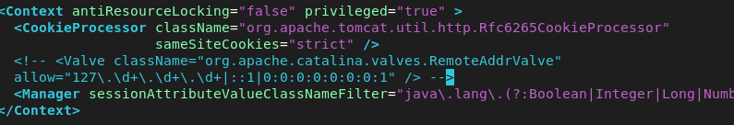

if your going with tomcat-9 and below others give execute Permission.
# Go to bin directory.
cd /opt/tomcat/bin
chmod +x catalina.sh startup.sh shutdown.sh
4.2 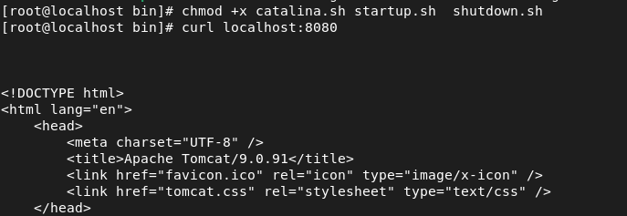
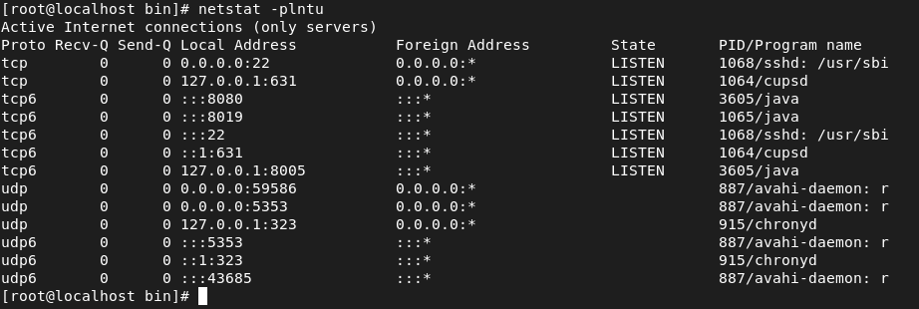
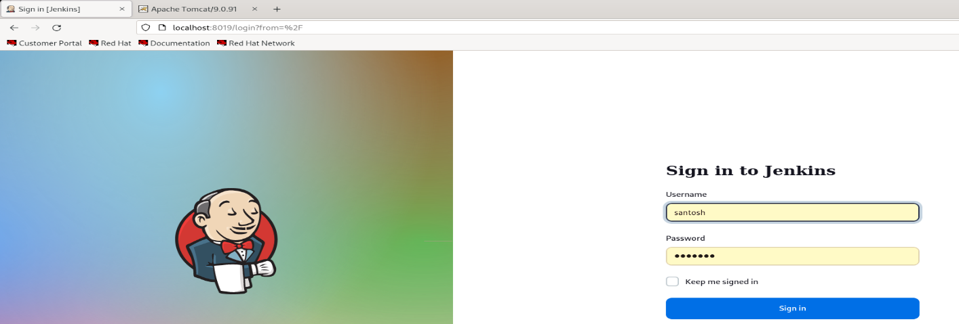
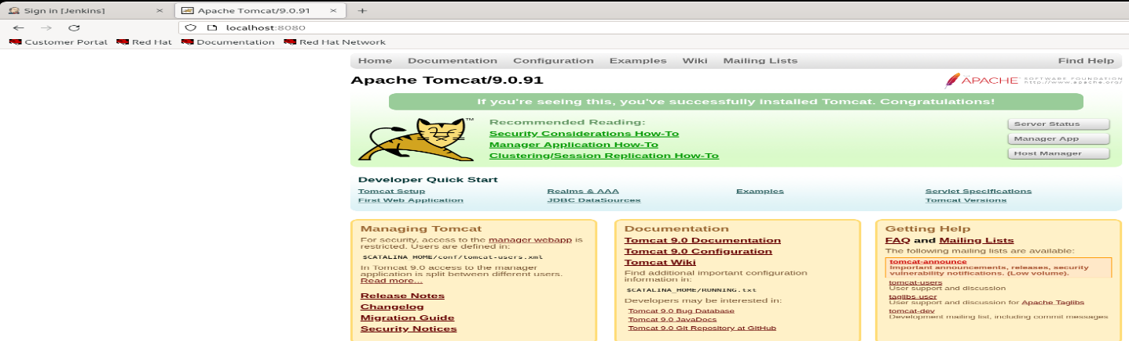
Now login into Jenkins UI and follow the steps as shown to deploy java application.
5.1 Jenkins UI Manage Jenkins Tools (or) Global Tool Configuration.
Then scroll down to find git installation. Click on add Git then select Git.
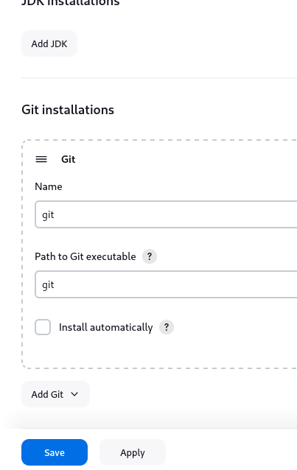 then save&apply. Now again , Jenkins UI -> Manage Jenkins -> Tools (or) Global Tool Configuration. And scroll down to select Maven installation.
5.2 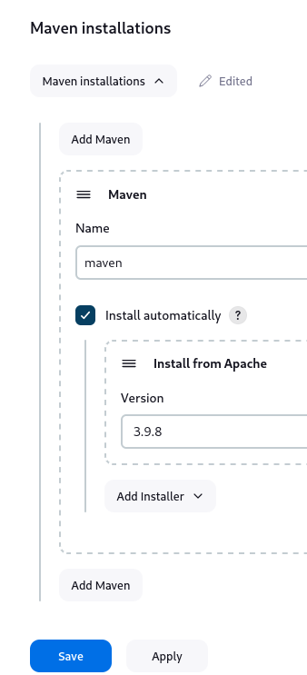 then save & apply
Now , Jenkins UI -> Manage Jenkins -> Plugins
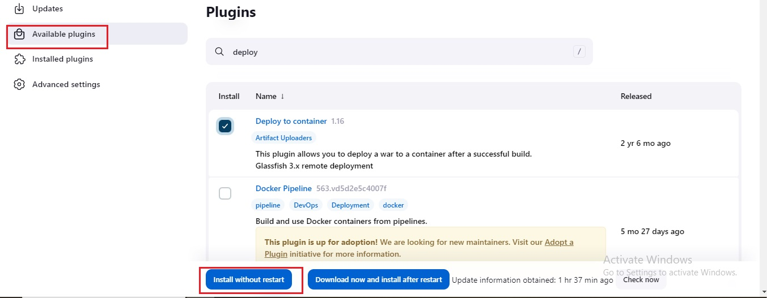
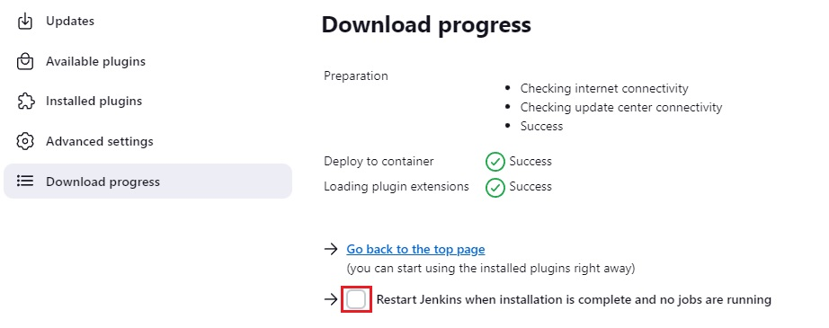
Go to Manage Jenkins and Click on Credentials use the same credentials you used in tomcat , check it in tomcat-user.xml
Now go to , Jenkins UI => Manage Jenkins => Credentials , and select system.
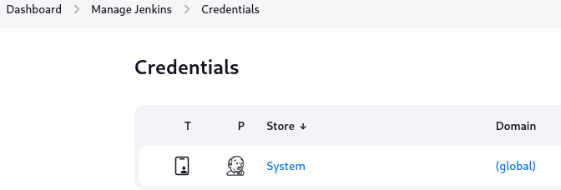
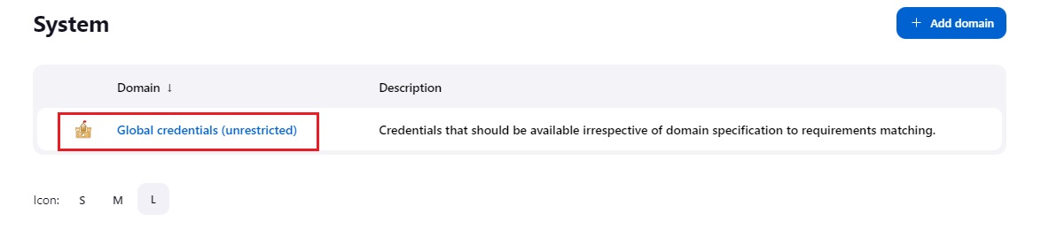
Enter username and password in the NEW CREDENTIALS.
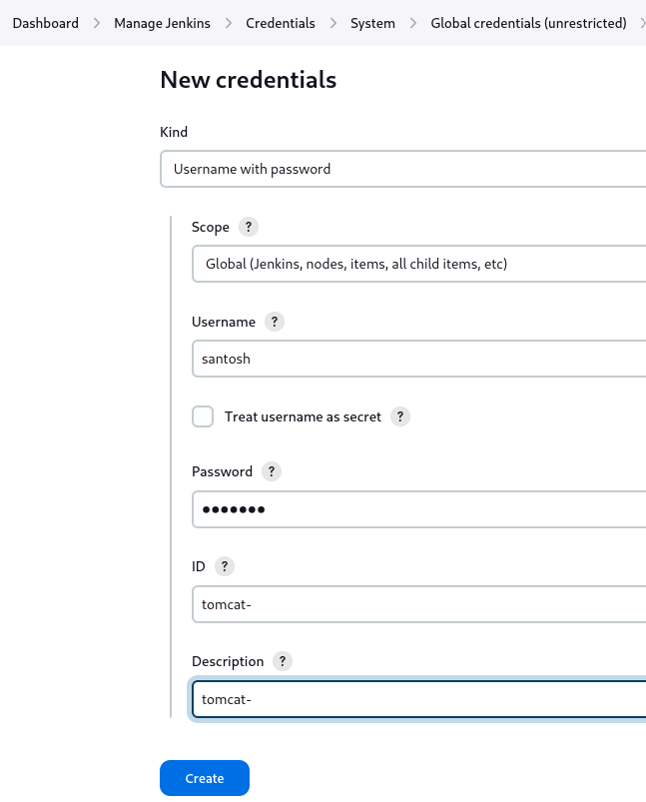 and create.
After this it will look like this.
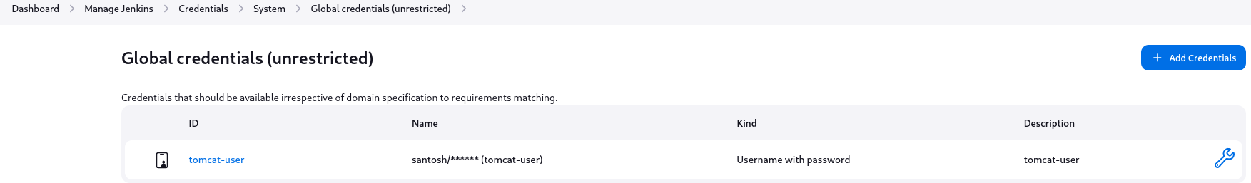
Now lets create a Jenkins job .
- Jenkins UI -> New Item -> Free Style Project -> then it will move to general.
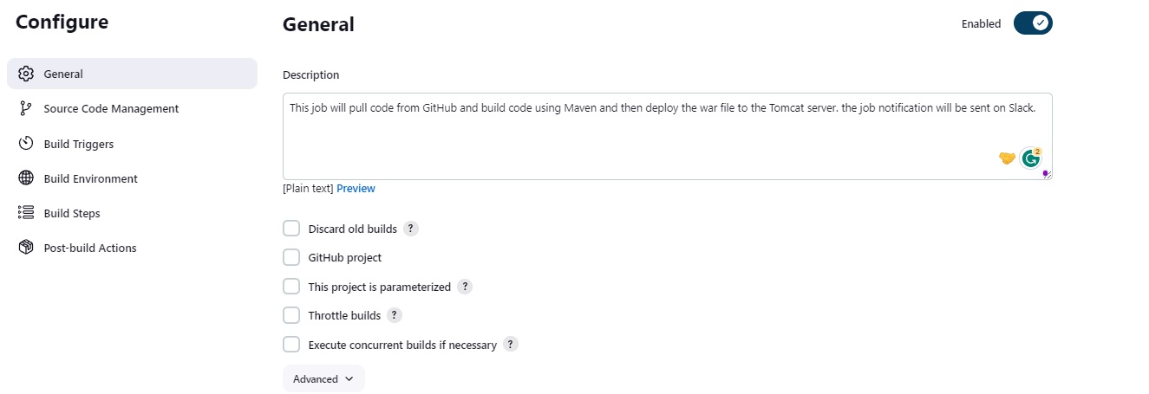
https://github.com/sampathshivakumar/Java-Web-Apps.git paste it in the repository url.
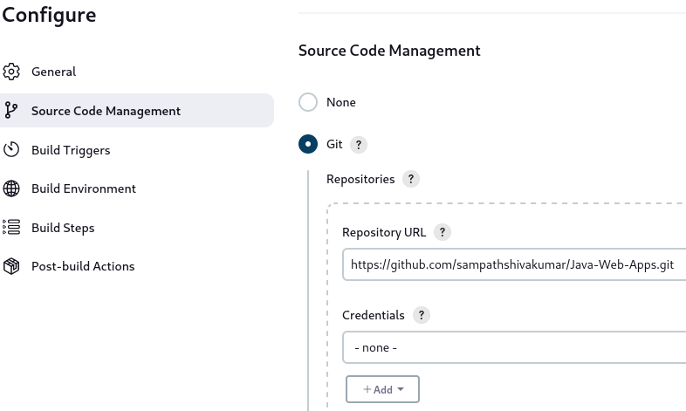
Under repository session , you will see branch set it to main.
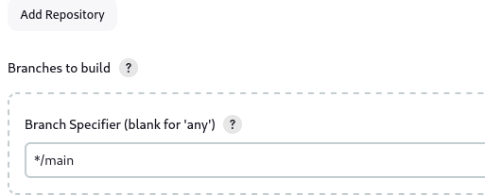 then
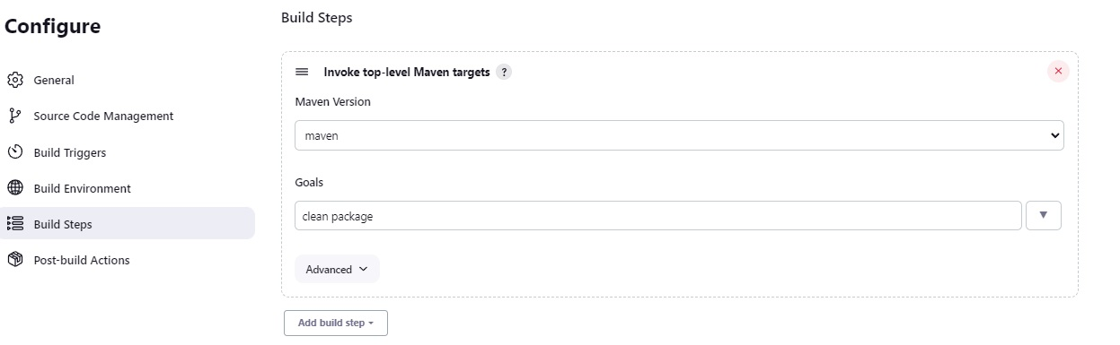
Enter the details as following then click on apply and save.
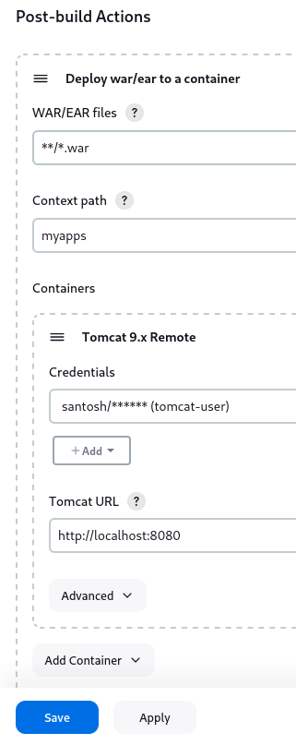 then apply & save and use Build Now option to build your project.
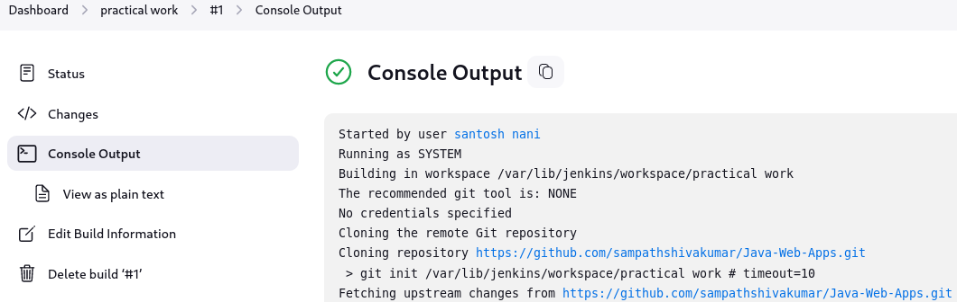
Once your build is successful then u can see it in your browser with
Localhost:8080/myapps/

